Comparative Analysis of Air Quality and Major Pollutants in India
1. Project Title
Comparative Analysis of Air Quality and Major Pollutants in India
2. Attribute (Column / Feature) Details
Below are the been Transformed and provided with appropriate Dataypes as well as with the Column Description
Attribute Name | Data Type | Description
country | Text (String) | Name of the country where air quality data is recorded (India in this dataset)
state | Text (String) | Name of the Indian state where the monitoring station is located
city | Text (String) | Name of the city or region where air quality is measured
stationName | Text (String) | Name or unique identifier of the air quality monitoring station
stationCity | Text (String) | City associated with the monitoring station (may differ from administrative city)
monitoringBoard | Text (String) | Authority or board responsible for air quality monitoring
lastUpdate | Date / DateTime | Date and time when pollutant data was last updated
Latitude | Number (General) | Geographic latitude of the monitoring station
Longitude | Number (General) | Geographic longitude of the monitoring station
pollutantId | Text (String) | Code or identifier representing the pollutant
pollutantCategory | Text (String) | Name/category of the pollutant (PM2.5, PM10, NO₂, SO₂, CO, O₃)
pollutantMin | Number (General) | Minimum pollutant concentration recorded
pollutantMax | Number (General) | Maximum pollutant concentration recorded; used to identify worst air quality
pollutantAvg | Number (General) | Average pollutant concentration used for comparison and trend analysis

3. Data Modelling:
Fact Table: Fact_AQI
The Fact_AQI table stores measurable air quality readings collected at monitoring stations.
It represents the transactional/measurement data.
Fact Table Contains:
- Quantitative values
- Foreign keys
- Event-based data
Dimension Tables Contain:
- Descriptive attributes
- Hierarchies
- Grouping columns
- Unique primary keys

Columns in Fact Table
Column Name | Type | Description
stationName | Key | Links to Dim_Station
pollutantId | Key | Links to Dim_Pollution
lastUpdate | Date | Date & time of AQI reading
pollutantAvg | Measure | Average pollutant value
pollutantMin | Measure | Minimum pollutant value
pollutantMax | Measure | Maximum pollutant value

Dimension Tables
Dimension tables store descriptive information used for filtering, grouping, and slicing data.
1. Dim_Station
Stores details about monitoring stations.
Column Name | Description
stationName (PK) | Unique station identifier
stationCity | City of station
Latitude | Geographical coordinate
Longitude | Geographical coordinate
monitoringBoard | Governing authority
2. Dim_Location
Stores geographical hierarchy.
Column Name | Description
city | City name
state | State name
country | Country name

3. Dim_Pollution
Stores pollutant classification information.
Column Name | Description
pollutantId | Unique identifier (primary key) for pollutant
pollutantCategory | Type of pollutant (e.g., PM2.5, NO₂, etc.)

3. Relationships with Tables
- Fact_AQI
  - The central fact table storing air quality measurements.
  - Fields: city, lastUpdate, pollutantAvg, pollutantCategory, pollutantId, pollutantMax, pollutantMin.

- Dim_Station
  - Contains details about monitoring stations.
  - Fields: city, Latitude, Longitude, monitoringBoard, stationCity, stationName.

- Dim_Pollution
  - Holds metadata about pollutants.
  - Fields: pollutantCategory, pollutantId.
- Dim_Location
  - Provides geographical context.
  - Fields: city, country, state.
Relationships
- Fact_AQI ↔ Dim_Station: Links air quality readings to the station where they were recorded.
- Fact_AQI ↔ Dim_Pollution: Connects pollutant measurements to pollutant categories and IDs.
- Fact_AQI ↔ Dim_Location: Associates readings with broader location details (city, state, country).
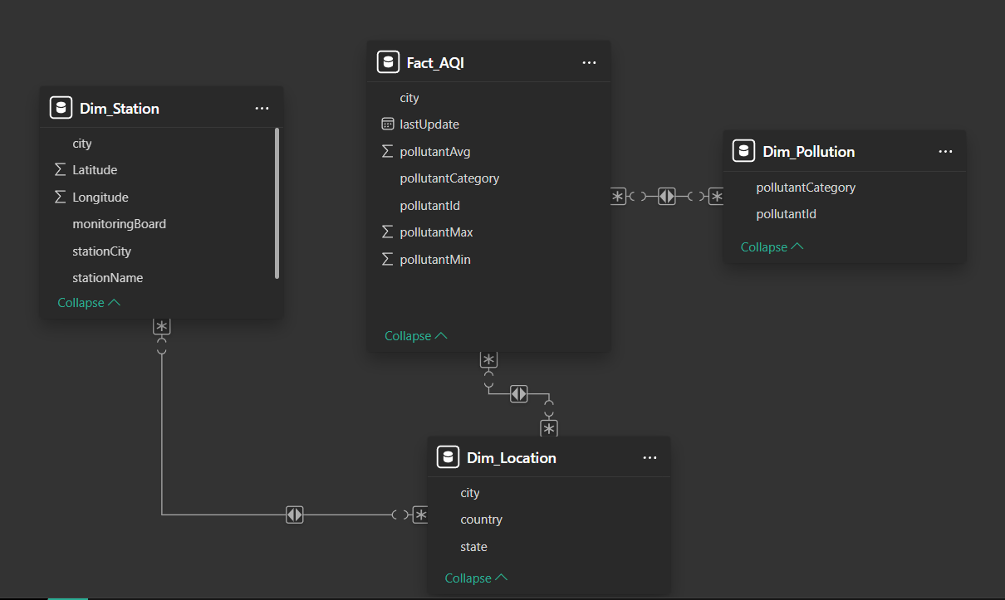

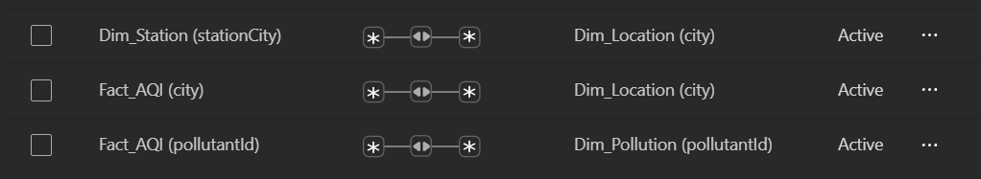

Dashboard Objective
The objective of this dashboard is to analyze air pollution levels across different states, cities, and monitoring stations in India. It provides dynamic insights into pollution distribution, most affected regions, and pollutant category performance using interactive visuals and DAX measures.
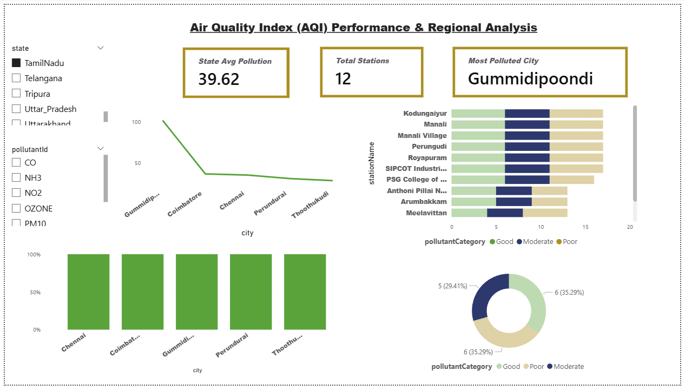
Key Performance Indicators (KPIs)
1. State Average Pollution
Displays the average pollutant concentration based on selected state and pollutant.
State Avg Pollution = AVERAGE(Fact_AQI[pollutantAvg])
2. Total Monitoring Stations
Counts distinct monitoring stations in the selected context.
Total Stations = DISTINCTCOUNT(Dim_Station[stationName])
3. Most Polluted City
Identifies the city with the highest average pollution level dynamically.
Most Polluted City =
VAR CityTable =
ADDCOLUMNS(
VALUES('Dim_Station'[city]),
"AvgPollution",
CALCULATE(AVERAGE('Fac_tbl_AQI'[pollutantAvg]))
)
VAR TopCity =
TOPN(1, CityTable, [AvgPollution], DESC)
RETURN
MAXX(TopCity, 'Dim_Station'[city])

Visualizations Used in Dashboard
1. Line Chart – City-wise Pollution Trend
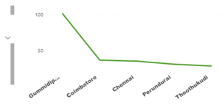
- Axis: City
- Values: Average of pollutantAvg
- Purpose: Shows comparative pollution levels across cities.
- Insight: Cities with consistently higher average pollutant values stand out as hotspots. Seasonal or temporal spikes can be identified, showing when pollution worsens (e.g., winter months often see higher PM2.5 due to stubble burning and weather conditions).
2. Stacked Bar Chart – Station-wise Pollution Category
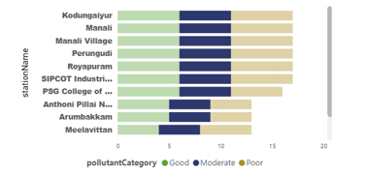
- Axis: stationName
- Legend: pollutantCategory
- Values: Count of pollutantId
- Insight: Reveals which stations report higher counts of specific pollutants (e.g., NO₂ near traffic-heavy zones, SO₂ near industrial hubs). Stations with diverse pollutant categories indicate complex pollution sources.
3. Donut Chart – Pollution Category Distribution
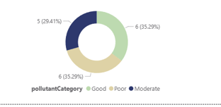
Purpose: Shows overall pollution category percentage.
- Legend: pollutantCategory
- Values: Pollutant Count
- Insight: Highlights dominant pollutants (e.g., PM2.5 and PM10 often form the largest share). If particulate matter dominates, it indicates severe health risks related to respiratory issues.
4. Column Chart – City-wise Average Pollution
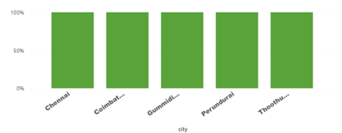
Purpose: Identifies highly polluted cities visually.
- Axis: City
- Values: Average pollutantAvg
- Insight: Identifies the most polluted cities dynamically. Cities with consistently high averages can be flagged as critical zones for intervention.

Slicers Implemented
- State
- Pollutant ID
These slicers dynamically filter all visuals and KPIs in the dashboard.

Analysis:
1. Descriptive Analysis (What happened?)
- Objective: Summarize and visualize the current state of air quality across India.
- Dashboard Role:
  - Line chart shows city-wise pollution trends over time.
  - Column chart highlights average pollution levels per city.
  - Donut chart reveals pollutant category distribution (e.g., PM2.5, PM10 dominating).
  - Stacked bar chart compares pollutant categories across stations.
- Insight: Provides a snapshot of pollution levels, most polluted cities, and dominant pollutants. For example, PM2.5 and PM10 are consistently the largest contributors, with northern cities showing higher averages.
2. Diagnostic Analysis (Why did it happen?)
- Objective: Identify root causes and drivers behind pollution levels.
- Dashboard Role:
  - Station-wise pollutant categories help pinpoint sources of pollution (e.g., NO₂ near traffic-heavy stations, SO₂ near industrial zones).
  - Location dimension (state, city, country) allows comparison across regions to detect geographical drivers.
- Insight:
  - Seasonal spikes (winter smog, stubble burning) explain temporal increases.
  - Industrial clusters contribute to SO₂, while urban traffic explains NO₂.
  - Cities with fewer monitoring stations may underreport pollution, showing gaps in data coverage.
3. Predictive Analysis (What is likely to happen?)
- Objective: Forecast future pollution trends using historical data patterns.
- Dashboard Role:
  - Line chart trends can be extended with forecasting models (e.g., exponential smoothing, ARIMA).
  - Pollutant averages can be projected to predict future AQI levels.
- Insight:
  - Cities with consistently high averages are likely to remain hotspots unless interventions occur.
  - Seasonal forecasting can predict winter smog events or post-harvest spikes in PM2.5.
  - Predictive modeling can highlight emerging risk zones before they reach critical levels.
4. Prescriptive Analysis (What should be done?)
- Objective: Recommend actions to improve air quality based on insights.
- Dashboard Role:
  - KPIs like Most Polluted City and State Average Pollution guide prioritization.
  - Slicers (state, pollutant ID) allow scenario testing — e.g., “What if we reduce PM2.5 in Delhi by 20%?”
- Insight:
  - Focus interventions on cities with highest averages (Delhi, Lucknow, Kanpur).
  - Target dominant pollutants (PM2.5, PM10) with stricter emission controls.
  - Expand monitoring stations in underrepresented states for better coverage.
  - Prescriptive models can simulate policy impacts (e.g., vehicle restrictions, industrial emission caps).
Summary
- Descriptive: Shows current pollution levels and distribution.
- Diagnostic: Explains causes (traffic, industry, seasonal factors).
- Predictive: Forecasts future pollution trends and hotspots.
- Prescriptive: Suggests actionable strategies to reduce pollution.
Conclusion
The AQI dashboard provides a comprehensive analytical view of air pollution trends across India. By implementing star schema modeling, optimized DAX measures, and interactive visuals, the report enables efficient monitoring and decision-making for environmental assessment.

